

CHRISTMAS MESSAGE
ARCHBISHOP MARTINS URGES NIGERIANS NOT TO SUCCUMB TO FEAR, PREACHES HOPE, LOVE AT CHRISTMAS!
Lagos, Nigeria. 23rd December 2025.

In a solemn and urgent Christmas message, the Catholic Archbishop of Lagos, His Grace, Most Rev. Dr. Alfred Adewale Martins, has expressed the need for giving thanks to God for the joy of celebrating another Christmas despite many challenges that we face individually and as a country. He declared that Nigeria is right in the middle of a tide of criminal violence, fear, and a feeling of despair among many citizens.
He therefore called for people not to lose hope but live in the hope that can be assured only by God himself, the one in whom hope does not disappoint. As we hope in God, he said: “We must also insist that everyone, especially those in government at all levels and all politicians should work intentionally, in order to generate hope in our people; not simply by empty platitudes, but in courageous and meaningful action to stem the tide of fear and criminal activities in the land”.

In his 2025 Christmas message signed by the Director of Social Communications, Very Rev. Fr. Anthony Godonu, he lamented that the government has not done enough to provide the most fundamental assurance to its citizens: the hope of a secure and dignified future.

Archbishop Martins said: “while we are not oblivious of the efforts being made by the government, we must also admit that the present reality of insecurity and pervasive fear have made it almost impossible for the average Nigerian to thrive or even dream with confidence”. We must continue to challenge the nation’s leadership to urgently bring an end to the kidnappings and killings and so give assurance to communities of people who feel that they are being targeted and under siege by criminal elements in the country. Our citizens do not need mere promises but decisive action that secures our farms, our roads, our schools, and our places of worship. After all said and done, the primary duty of the state is to protect the life and properties of her citizens.
On another note, Archbishop Martins urged Nigerians not to succumb to despair and despondency. “The coming of Christ at Christmas is God’s definitive entry into a world of struggle and a potent intervention in human history. So, our hope is not a distant reality but a call to embody his presence here and now as we show love, empathy and kindness towards one another, especially those who are most in need among us. We must all remember that the true essence of this season lies in a selflessness that fights for justice, a humility that serves the broken among us, and a love that dismantles walls of division”.

The Archbishop’s message concluded with a powerful vision of national renewal. “The national transformation that we long for will surely come,” Archbishop Martins said, “if we all choose to obey the fundamental commandments of God; to love Him and our neighbor but also to uphold the rule of law.
We must learn to live at peace with one another, irrespective of religion, tribe, or political affiliation.” “Let this Christmas be a turning point,” he urged. “Let us put aside hatred, embrace our shared humanity, and work tirelessly to build a Nigeria where every person can live with dignity, free from fear and oppression. Let us build bridges, not walls. The light of Christ, shining in our hearts and actions, is the sure foundation for the brighter future we all seek,” he said.
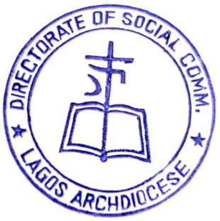
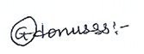

Very Rev. Fr. Anthony Godonu
Director of Social Communications

